**House Rules**

**FOR THE GUTENBERG MUSEUM**

**Liebfrauenplatz 5, Mainz**

Dear visitors,

We welcome you very warmly in our museum and wish you a pleasant stay. At the beginning of your visit we would like to familiarize you with our house rules.

**Purpose of the house rules**

1. The house rules are intended to make your visit to the museum as pleasant as possible.
2. The house rules are binding for all visitors. By entering the museum building, you accept our regulations as well as all other instructions issued to maintain operational safety
3. The management, represented by the employees, exercises the householder's rights. Instructions must therefore be followed.



**Visitors to the museum**

1. We are happy to welcome children, young people and adults.
2. Parents or other adult companions are not released from their supervisory duties when visiting the museum with underage children.
3. Stairs, passages and designated escape routes must always be kept clear for safety reasons.

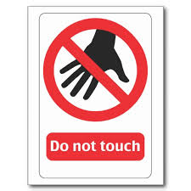**Securing the exhibits and behaviour in the exhibition rooms**

1. In order not to damage the exhibits, we kindly ask you not to touch the showcases. The exhibits where touching is desired are marked. Please leave all objects that could pose a danger to the exhibits at the cloakroom.
2. Animals are not permitted in the museum.
3. Eating and drinking is not permitted in the rooms of the museum.
4. Teachers, group leaders and guardians are asked to pay attention to the appropriate behaviour of the children and young people and to stay with the group at all times.
5. We kindly ask you to refrain from doing anything that might be detrimental to the safety and order in the museum, such as running around the rooms. You are liable for any damage caused by your behaviour.

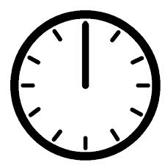 **Entrance fees and opening hours**

1. The admission fees and opening hours of the Gutenberg Museum are fixed Special openings are possible after checking the application.
2. In the event of overcrowding or for special reasons, the museum may be closed to visitors in whole or in part.
3. Tickets are valid for the day of purchase and are not transferable. Visitors are obliged to keep the ticket until the end of the valid opening hours. Visitors must leave the museum by the end of the valid opening hours at the latest.

**Store coats and luggage**

Lockers or the unguarded cloakroom are available for storing your clothes and bags. For conservatory and security reasons, entering the exhibition rooms with bulky or wet objects such as umbrellas, rainwear, backpacks and bags cannot be tolerated. In case of doubt, the service personnel will decide. Liability on the part of the cloakroom or locker holder is excluded.

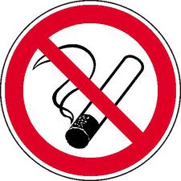 **Smoking ban**

According to the Non-Smoker Protection Act of Rheinland-Pfalz, the museum is a smoke-free facility. This means that smoking is not permitted in the entire museum.

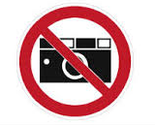**Photography and filming**

1. Photography for private purposes is permitted in the Gutenberg Museum. Flash photography and the use of tripods, selfie sticks, drones or similar aids are not allowed. Furthermore, photography and filming in the vault is generally not permitted for conservation reasons.
2. Photography and filming for commercial purposes or as part of daily news coverage requires prior agreement and written permission from the museum management.
3. If you wish to obtain written permission, please contact the Museum's Press and Public Relations Department on 06131/12 2211 or send an e-mail to presse.gm@stadt.mainz.de.

**Lost property**

Objects found in the museum are to be handed in at the cash desk. Lost property is disposed of in accordance with the legal regulations.

 **Supervisory staff**

It is the duty of the supervisory staff to ensure that the house rules are observed. We therefore ask you to follow the instructions of the supervisory staff. If the house rules or the instructions of the supervisory staff are not followed, the person in question may be prohibited from continuing to stay in the house. Visitors who repeatedly fail to comply with the house rules may be banned from the house. The admission fee will not be refunded if the visitor is expelled from the museum.

** Special Provisions for Corona Prevention (Status: May 2022)**

The following special conditions apply at the Gutenberg Museum with immediate effect:

1. Visitors and staff on the premises of the Gutenberg Museum are obliged to wear a mouth and nose protection. If a medical certificate proves that a guest cannot wear a mouth and nose protection for health reasons, a visit to the museum is still possible. On request, the medical certificate must be presented to the cashiers and supervisors.
2. Visitors are required to maintain a minimum distance of 1.5 to 2 metres in all rooms of the museum
3. In order to guarantee the minimum distance, only a certain number of visitors to the museum is allowed to be on the premises at the same time. The employees of the museum check that the maximum number of visitors is observed and, if necessary, regulate visitor traffic.
4. The route guidance system set up in the museum buildings must be followed.
5. In order to trace possible chains of infection, visitors to the museum are asked to leave their contact details upon entry. The provision of data by the persons concerned is voluntary. The data collected will be stored for 21 days and then destroyed. According to the data protection law in accordance with Art. 13 DSGVO, the persons concerned are informed about the processing of personal data.
6. The signs in the museum concerning hygiene and rules of conduct must be followed.

**We thank you for your understanding and wish you a pleasant, exciting and informative stay in our museum.**

The house rules come into force with immediate effect on 10.05.2022.

Mainz, 10.05.2022

Dr. Ulf Sölter

Director of the Gutenberg Museum